Double Eagle Operation Document

**Deposit and Withdrawal**

1. How to deposit encrypted assets?
2. On the home page, browse to the "supporting assets" section, and then click "access" of the asset you want to deposit.

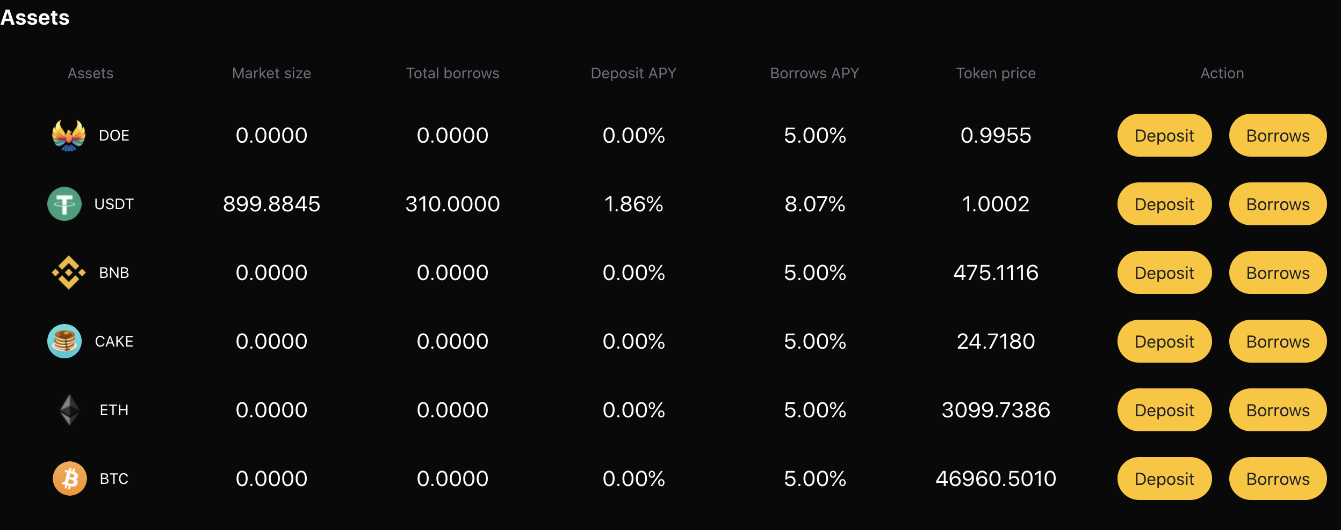

1. Select the asset category and quantity on the details page and submit your transaction. At present, we support digital assets such as doe, BNB, ETH, BTC, cake and usdt.

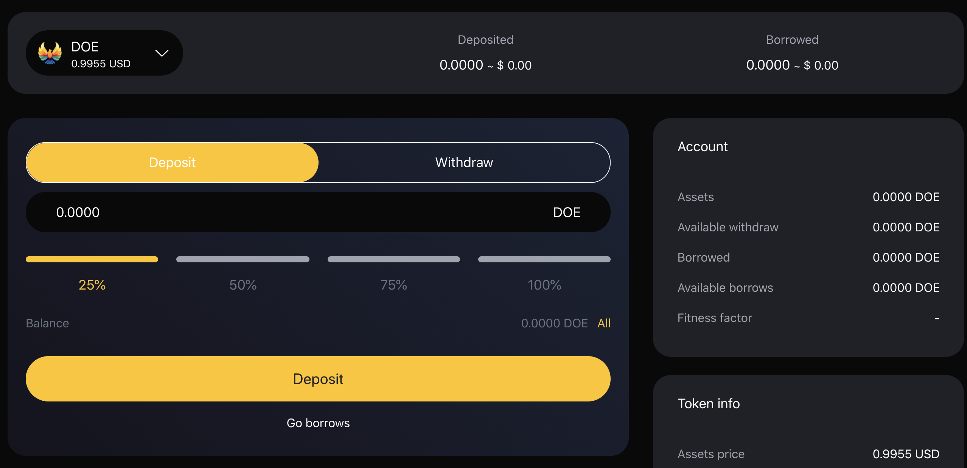

1. Once the transaction is confirmed, you will begin to earn interest.
2. How to withdraw money?
3. On the home page, browse to the "supporting assets" section, and then click "access" of the asset you want to deposit.



1. Select the asset category and withdrawal quantity on the details page and submit your transaction. The system will display your risk coefficient according to your access.

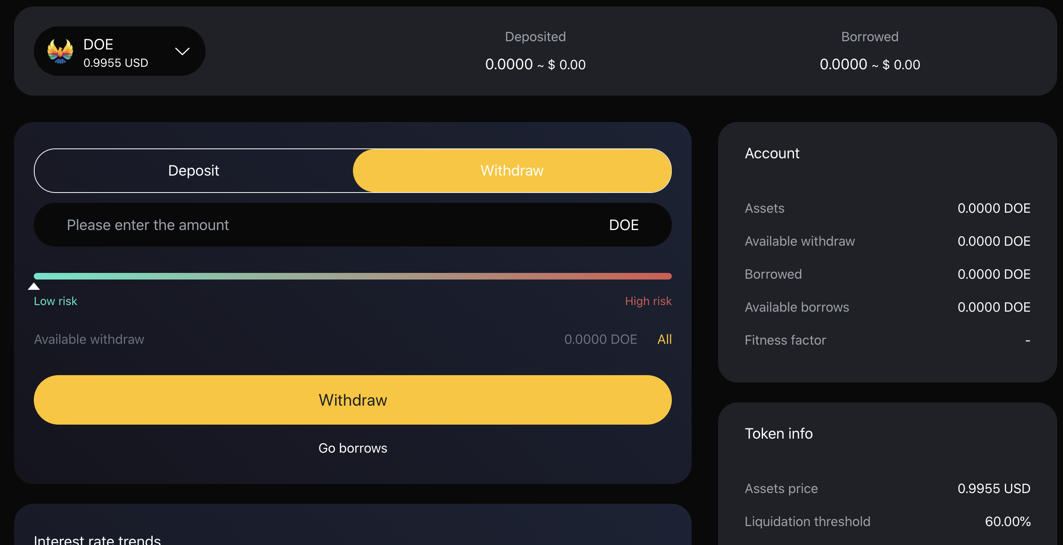

**Currency Borrowing And Repayment**

3. How to borrow money?

1. Before you need to borrow money, first ensure that you have deposited the relevant digital currency, then browse to the "supporting assets" section on the home page, and then click "borrow and return" of the asset you want to deposit.



1. Then click the digital currency you have saved, select the corresponding quantity, pay attention to the corresponding risk coefficient, and click the "borrow currency" button. And confirm the transaction.

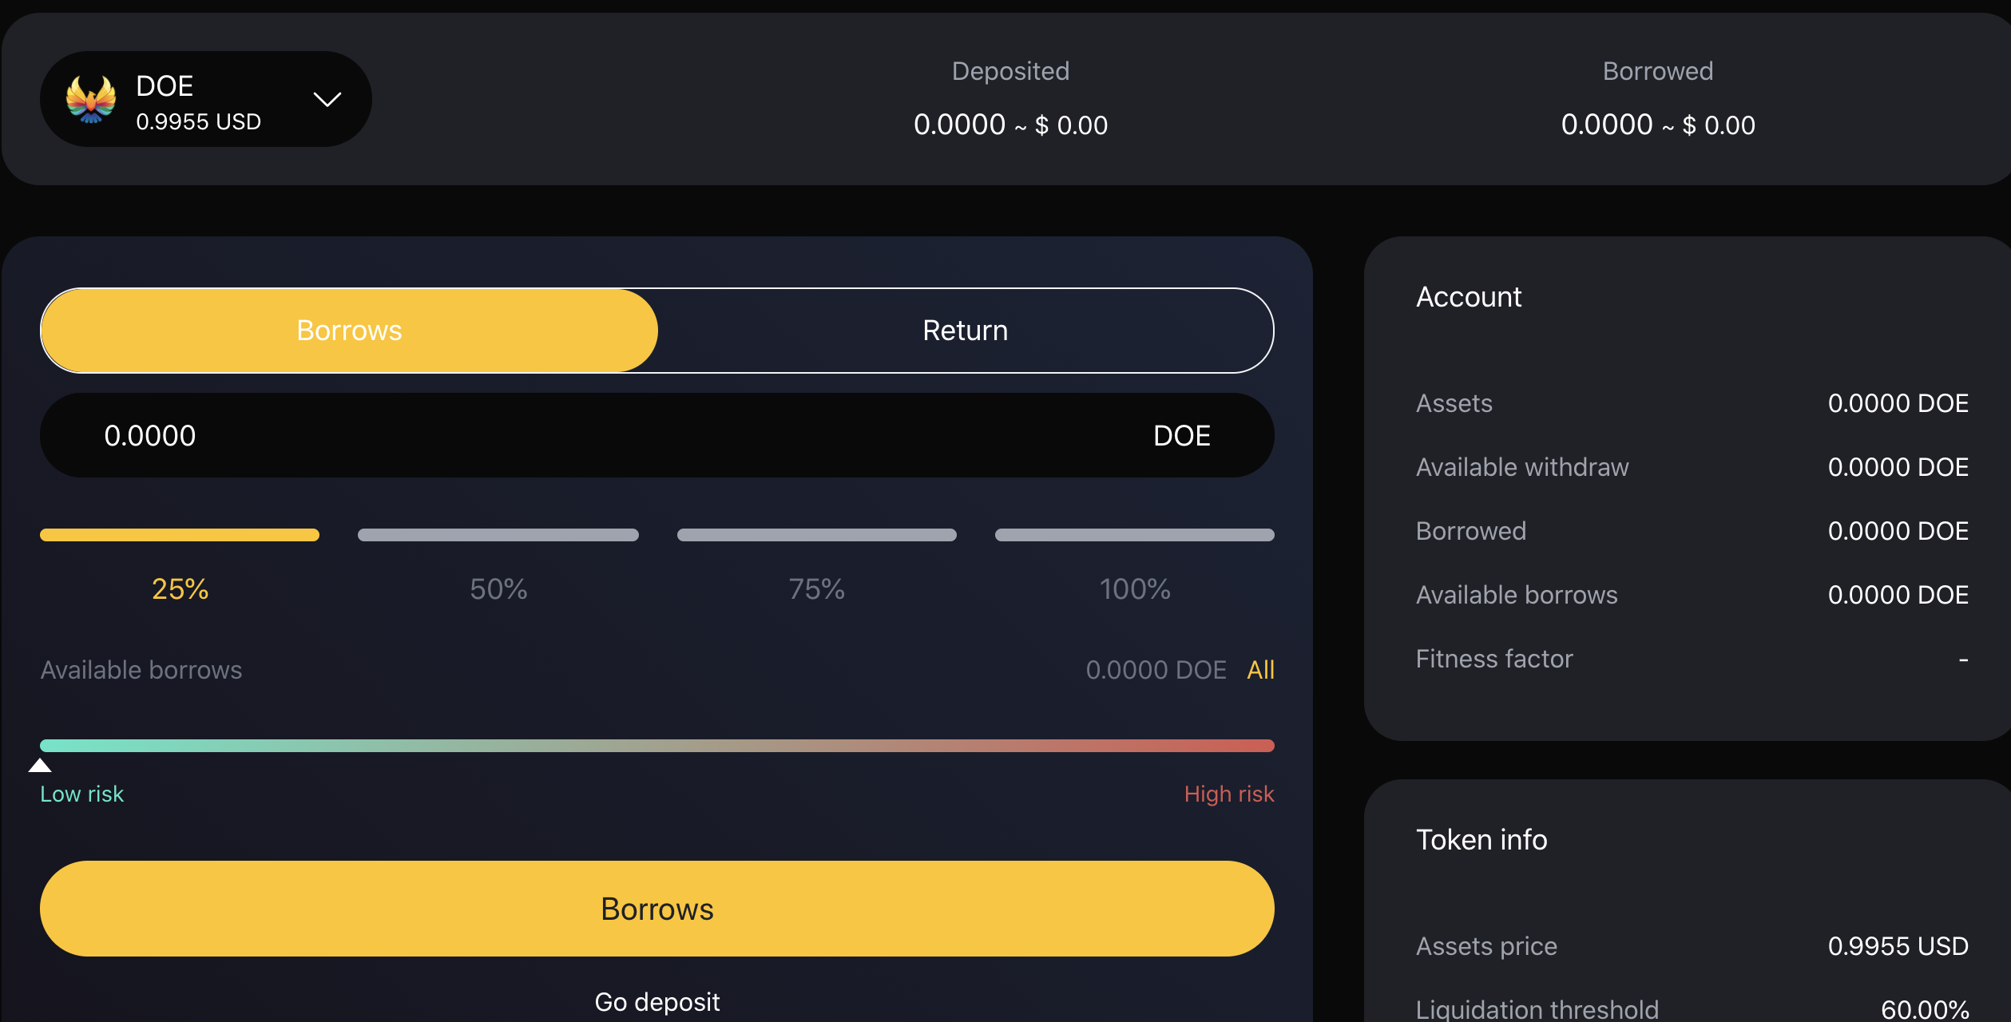

1. How to return money?
2. In order to repay the currency, you can browse to the "supporting assets" section on the home page, and then click "borrow / return" of the asset to deposit.



1. Then click the "return currency" button for the asset you borrowed and want to repay. Select the amount to be repaid and confirm the transaction.

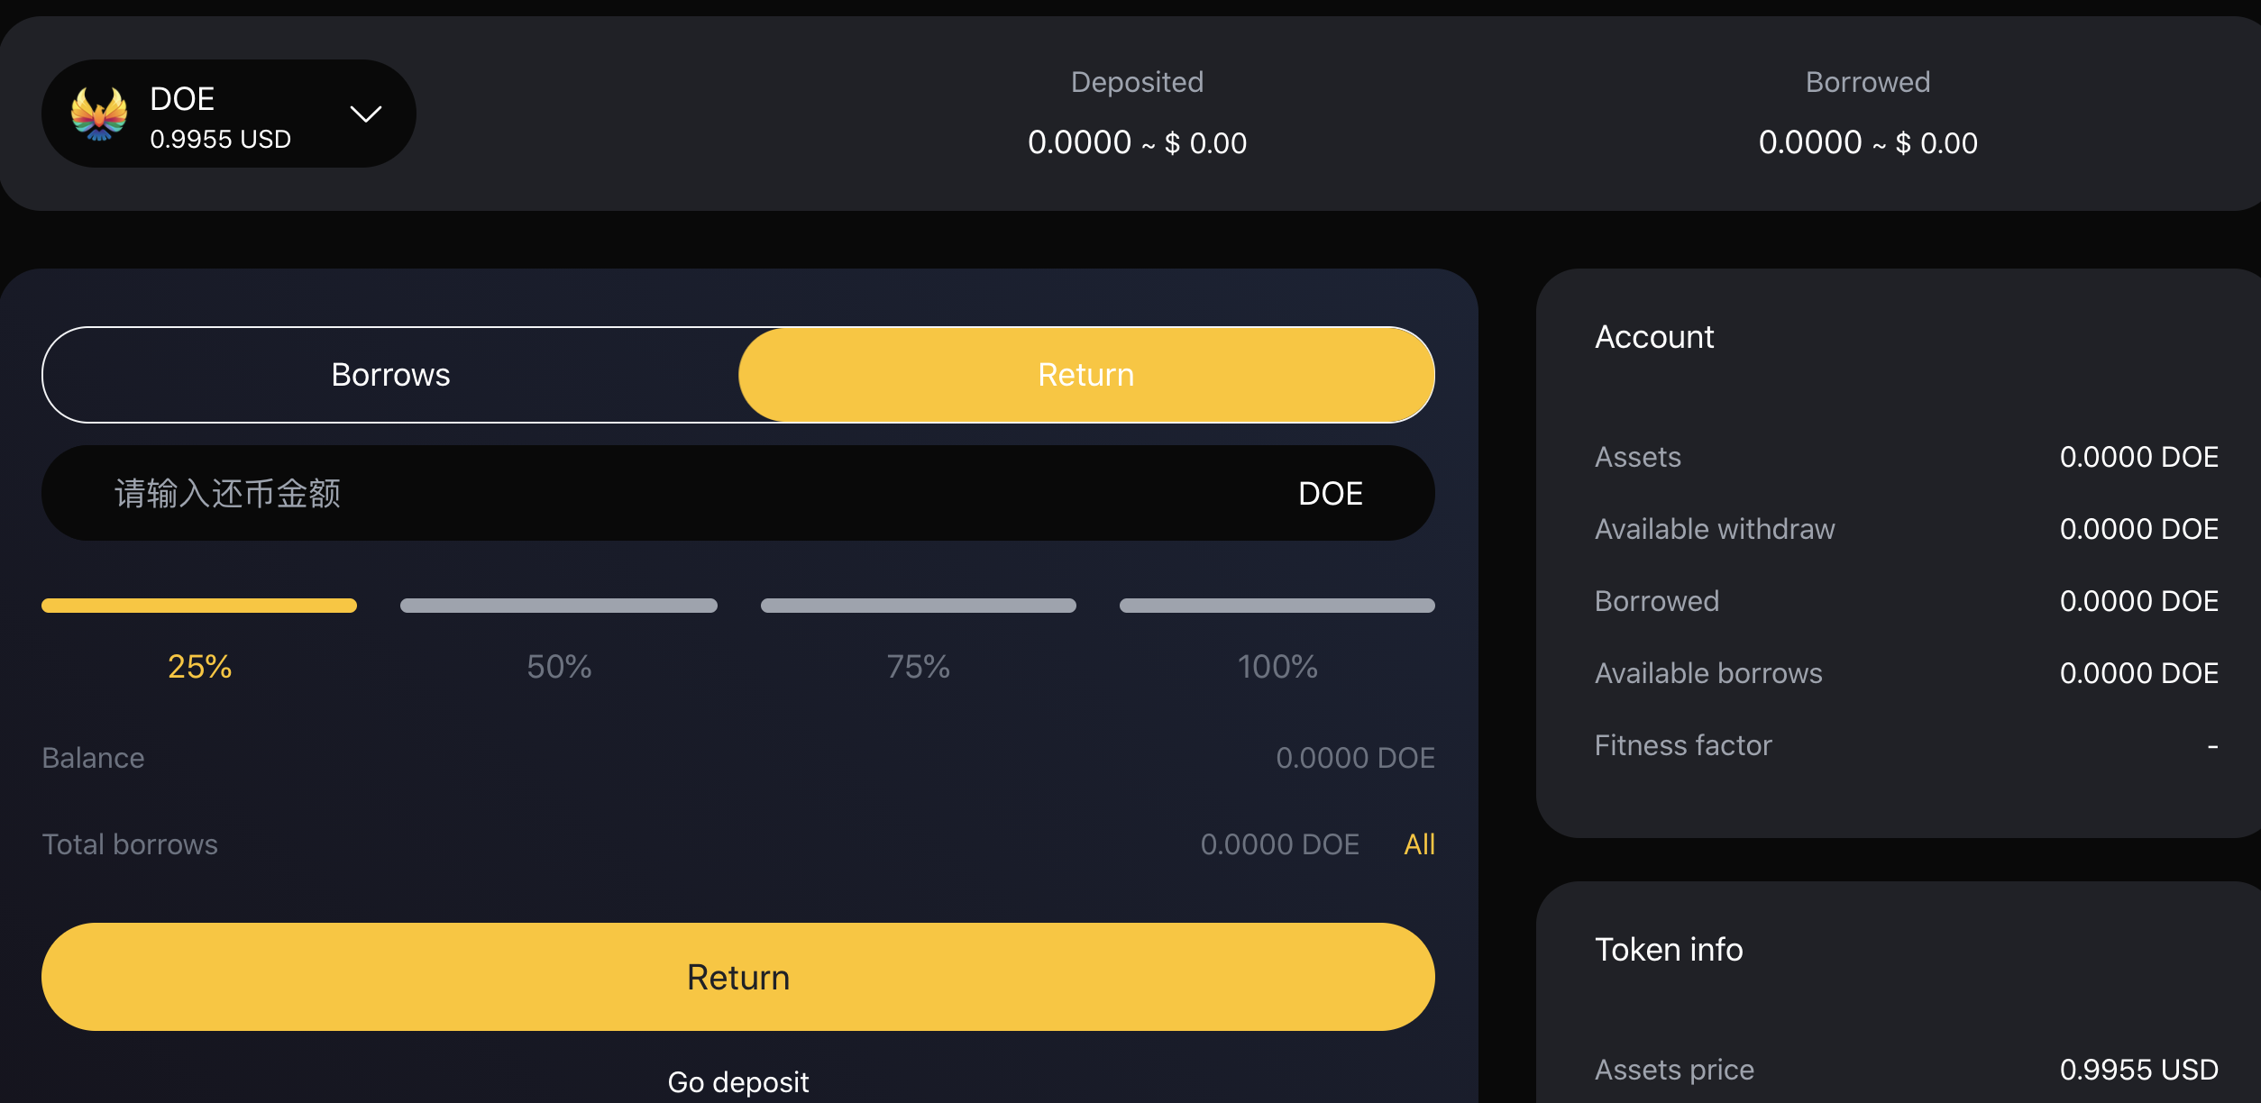

**Pledge**

1. How to pledge?
2. From the navigation "pledge" to enter the pledge module.

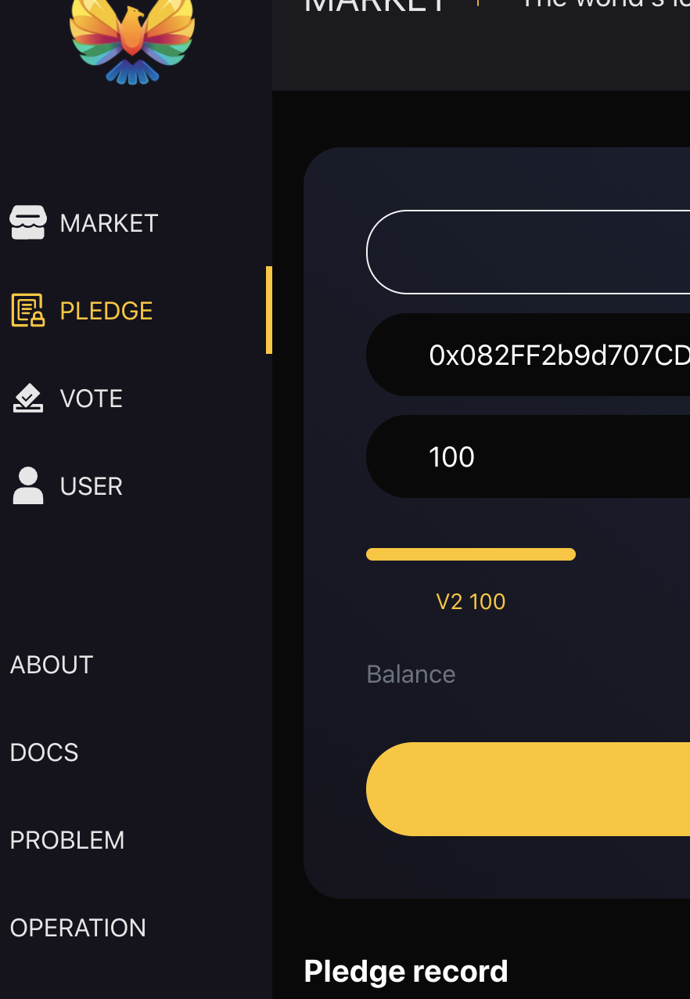

1. Enter the pledge details page, check the professional address, select the pledge level, and click the "pledge" button to complete the operation.

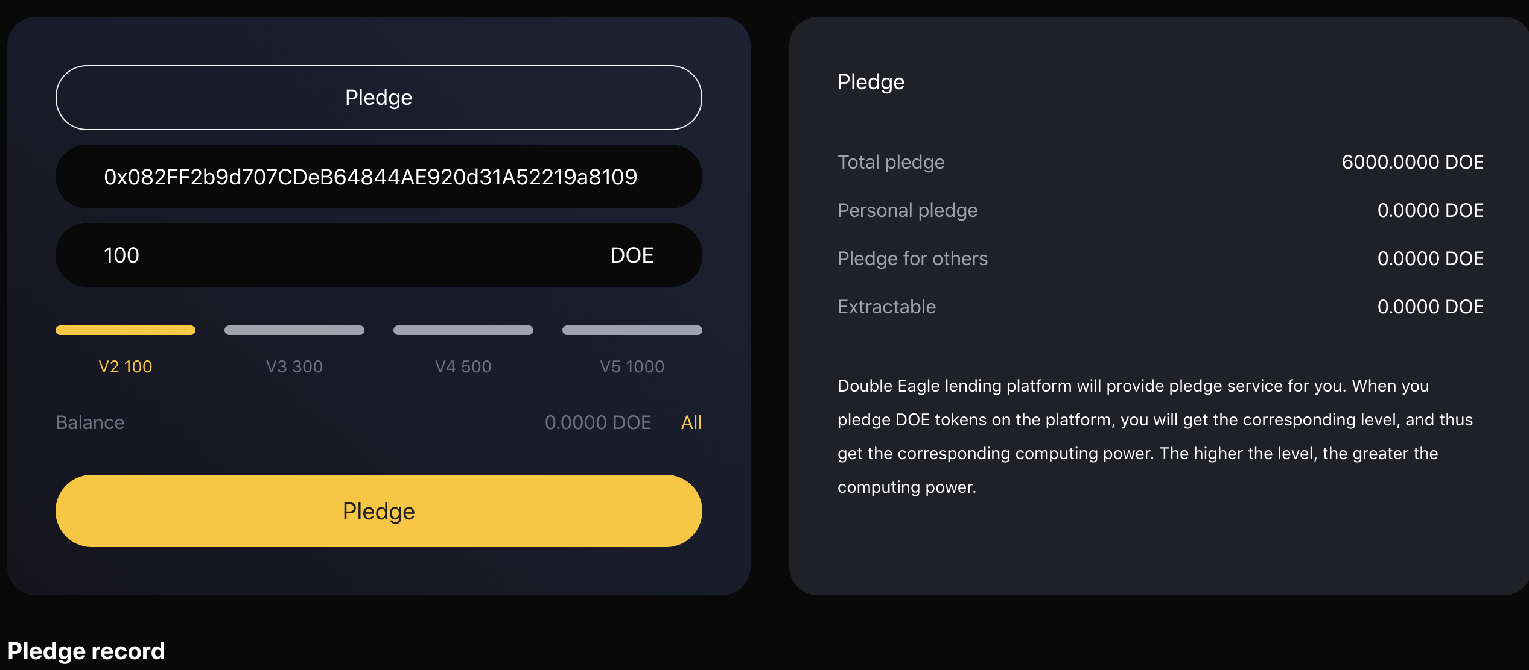

1. In "pledge record", you can see your pledge record

**Invitation**6. How to invite?

(1) Find the "invitation link" from the home page to copy the invitation link and QR code

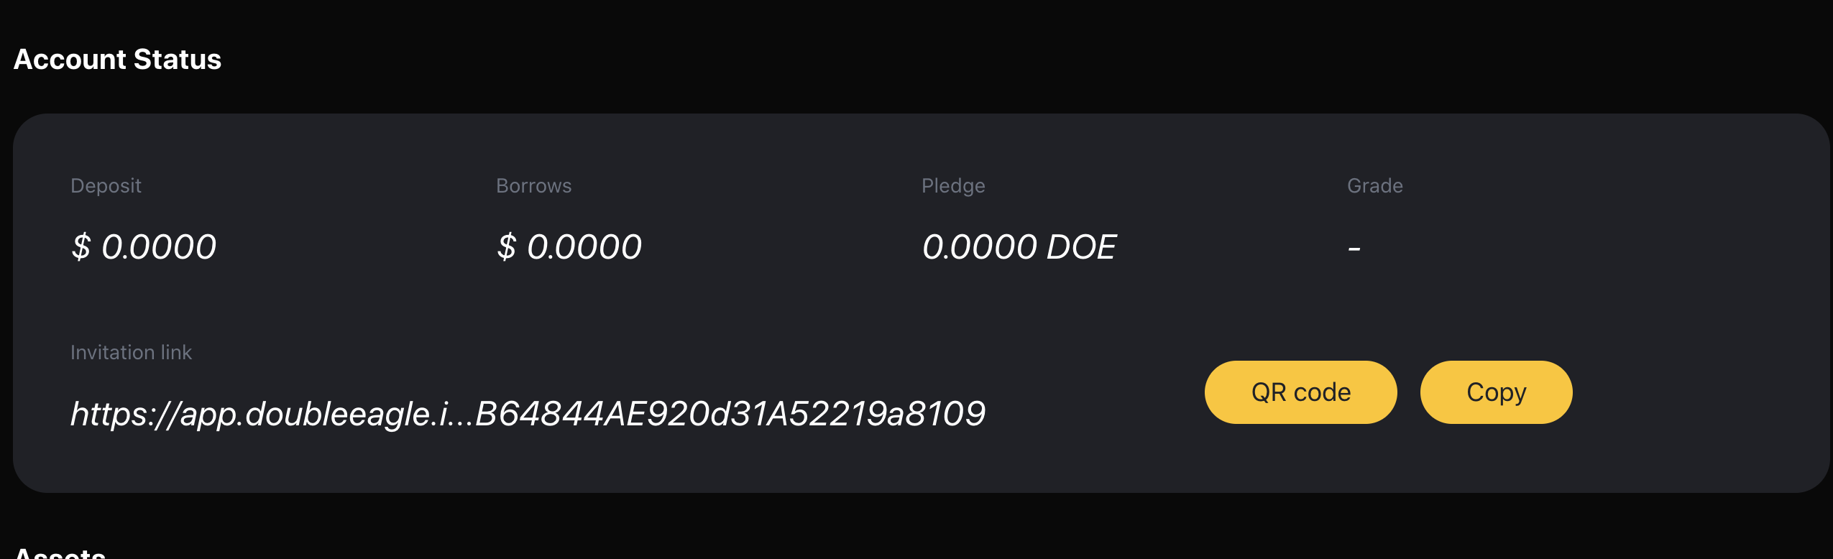

**Voting Governance**

1. How to vote?
2. Navigate to "vote" from the home page to enter the voting page for voting.

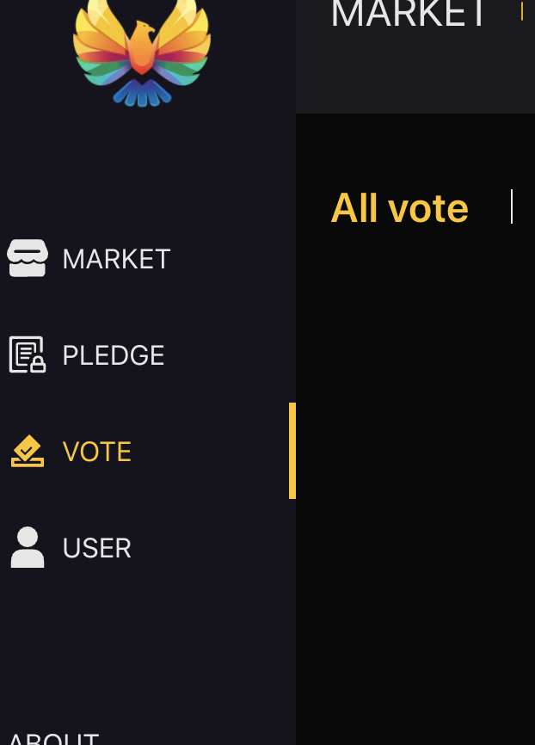

(2) Select relevant proposals

(3) Navigate to "vote" from the home page to enter the voting page and vote. You can choose "yes" or "no".